Task 2: Data Retrieval & Sorting Dashboard
Description: Create a page that displays student or employee records with:
Sorting by name or date
Filtering by department
Count of students per department

Aim
To design a dashboard that displays student records with features such as sorting by name or date, filtering by department, and counting the number of students in each department.

Algorithm:
Step 1: Start
Step 2: Create a database table with student details
Step 3: Insert sample student records into the table
Step 4: Connect the webpage to the database using PHP
Step 5: Retrieve all student records using SQL SELECT
Step 6: Provide sorting options:
- Sort by Name
- Sort by Date of Birth
Step 7: Provide filtering option:
- Filter students by Department
Step 8: Use SQL queries with ORDER BY for sorting
Step 9: Use SQL queries with WHERE for filtering
Step 10: Count number of students in each department using GROUP BY
Step 11: Display the results in a table format on webpage
Step 12: Stop

Program:

CREATE TABLE students (
id INT AUTO_INCREMENT PRIMARY KEY,
name VARCHAR(50),
email VARCHAR(50),
dob DATE,
department VARCHAR(20)
);

INSERT INTO students (name, email, dob, department) VALUES
('Ram', 'ram@gmail.com', '2003-05-14', 'CSE'),
('Priya', 'priya@gmail.com', '2002-07-20', 'IT'),
('Arun', 'arun@gmail.com', '2003-01-10', 'ECE'),
('Kiran', 'kiran@gmail.com', '2001-12-05', 'CSE');

PHP (Dashboard Logic)

<?php
$conn = new mysqli("localhost", "root", "", "student_db");

$order = isset($_GET['sort']) ? $_GET['sort'] : 'name';
$dept = isset($_GET['dept']) ? $_GET['dept'] : '';

$sql = "SELECT * FROM students";

if ($dept != '') {
$sql .= " WHERE department='$dept'";
}

$sql .= " ORDER BY $order";

$result = $conn->query($sql);

// Count per department
$count_sql = "SELECT department, COUNT(*) as total FROM students GROUP BY department";
$count_result = $conn->query($count_sql);
?>

HTML (Dashboard UI)

<!DOCTYPE html>
<html>
<head>
<title>Student Dashboard</title>
</head>
<body>

<h2>Student Dashboard</h2>

<form method="get">
Sort by:
<select name="sort">
<option value="name">Name</option>
<option value="dob">DOB</option>
</select>

Filter by Department:
<select name="dept">
<option value="">All</option>
<option value="CSE">CSE</option>
<option value="IT">IT</option>
<option value="ECE">ECE</option>
</select>

<button type="submit">Apply</button>
</form>

<h3>Student Records</h3>
<table border="1">
<tr>
<th>Name</th>
<th>Email</th>
<th>DOB</th>
<th>Department</th>
</tr>

<?php
while ($row = $result->fetch_assoc()) {
echo "<tr>
<td>{$row['name']}</td>
<td>{$row['email']}</td>
<td>{$row['dob']}</td>
<td>{$row['department']}</td>
</tr>";
}
?>

</table>

<h3>Department Count</h3>

<?php
while ($row = $count_result->fetch_assoc()) {
echo $row['department'] . " : " . $row['total'] . "<br>";
}
?>

</body>
</html>

Output:

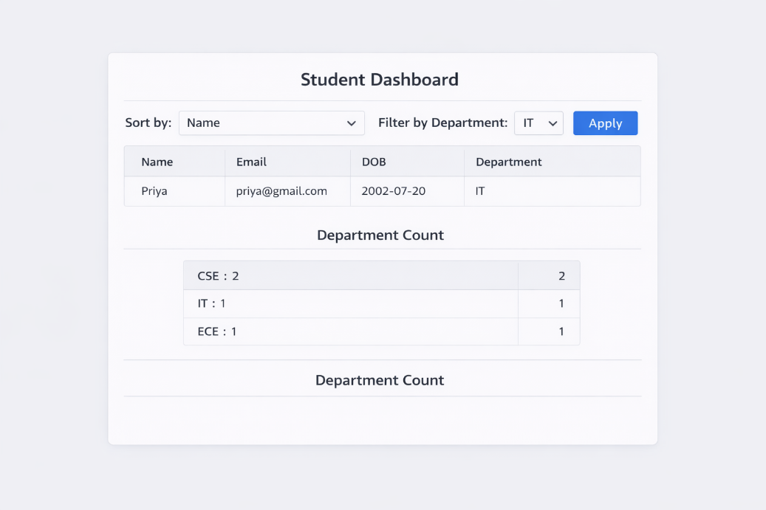

Result:
- The dashboard displays all student records in a table.
- Users can sort records by name or date of birth.
- Users can filter students based on department.
- The system counts and displays the number of students in each department.
- The dashboard works dynamically based on user selection.

